R_1 = Outer-most radius = 2.00
R_2 = Main diagonals = 1.00
R_3 = Fine = 0.5
R4 = Finest = 0.25

Initial structure:



Final distribution:


Plot of saturation of wetting fluid in the inner region with time:
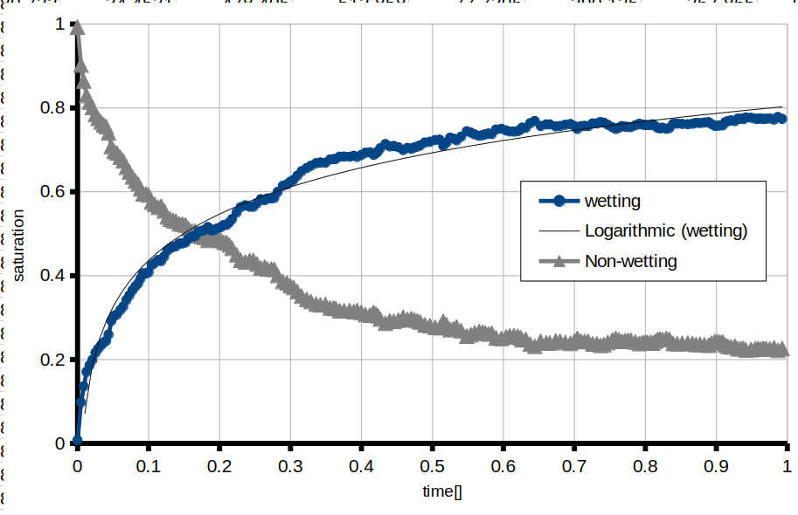

Capillary pressure vs saturation:

